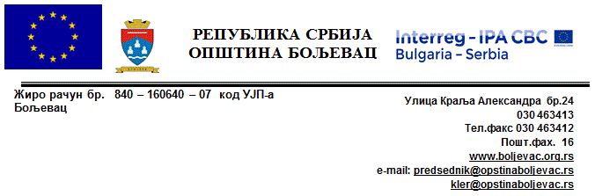
SUPPLIES CONTRACT AWARD NOTICE
Supply of equipment
Boljevac, Zajecar District, Serbia, SRB

1. Publication reference
CB007.1.31.348-LP-TD2.1

2. Publication date of the contract notice
06.03.2018.

3. Lot number and lot title
N/a

4. Contract number and value
Contract No. CB007.1.31.348-LP-TD2.1
Contract value: EUR 127.700,00

5. Date of award of the contract
25.05.2018.

6. Number of tenders received
3

7. Name, address and nationality of successful tenderer
Autocentar PEDA doo Jagodina Ltd
Kapetana Koče 91, 35000 Jagodina, Serbia
SRB

KARBA Automotive Machinery Industry
OSB Oguy Cad No 53/2 Sincan/Ankara
TUR
8. Duration of contract
5 (five) months, but not later than 18th October 2018.
9. Contracting Authority
Municipality of Boljevac
Kralja Aleksandra 24
19370 Boljevac, Republic of Serbia

10. Legal basis
Regulation (EU) N°236/2014 of the European Parliament and of the Council of 11 March 2014 laying down common rules and procedures for the implementation of the Union's instruments for financing external action and
Commission Implementing Regulation (EU) No 447/2014 of 2 May 2014 on the specific rules for implementing Regulation (EU) No 231/2014 of the European Parliament and of the Council establishing an Instrument for Pre-accession assistance (IPA II)
Commission Decision C (2015) 5444 adopting INTERREG IPA Cross-border Cooperation Programme Bulgaria – Serbia

